

**School of Information Technology**

**ITPV302**

**Bachelor of Information Technology (BIT)**

**Date**

***Business Case***

**Compiled by**

|  |  |  |  |
| --- | --- | --- | --- |
| **Lecturer** | **Student Name** | **Student Number** | **Date Submitted** |
| **Prof Bertram Haskins** | Nathan Rogers  Zanele Mndaweni  Max Naidoo | 221412581  225097524  225227053 |  |

Table of Contents

Table of Figures and Tables 2

Introduction 3

1.1 Meal planning and cooking for busy people 4

1.2 Project Objectives 5

1.3 Problem background 6

1.4 Related Systems Analysis 9

1.4.1 Recipe app name: Samsung Food 9

1.4.2 Recipe app name: SuperCook 10

1.4.3 Recipe app name: Yummly 11

1.5 Project Plan 12

1.6 Risk Analysis 14

1.6.1 Data Loss 14

1.6.2 Miscommunication about requirements 14

1.6.3 Power Outages 14

1.6.4 Skills gap within the team 14

1.6.5 Data Security Issues 14

1.6.6 Misalignment of project scope 14

1.6.7 Regulatory Compliance Issue 15

1.6.8 Team member illness/ Unforeseen Circumstances 15

1.6.9 Limited access to software (Trail software, require subscription) 15

1.6.10 Minor Bugs or Issues in the Code 15

1.6.11 Outdated project deliverable documents 15

References 16

# Table of Figures and Tables

Figure 1. 3: Samsung Food saving of recipes 9

Figure 1. 4: Samsung Food meal planner 9

Figure 1. 5: Samsung Food grocery list section 9

Figure 1. 6: SuperCook's shopping list manager 10

Figure 1. 7: SuperCook's ingredient filter 10

Figure 1. 8: SuperCook's favourites page with missing ingredient 10

Figure 1. 9: Yummly's meal planner 11

Figure 1. 10: Yummly's shopping list manager 11

Figure 1. 11: Yummly's nicely laid out Ingredients 11

Figure 1. 12: The Roadmap for the project (ITPV302_PROJECT_Plan, n.d.) 12

Table 1. 1: The major deliverables of the project 12

# Introduction

This business case document aims to give a comprehensive overview of our proposed solution to the challenges of planning meals and cooking in today’s fast-paced world. We aim to identify the various challenges that people face when preparing meals to then showcase the benefits of developing a recipe app that addresses these issues.

This document details our understanding of the problem domain and the proposed solution. This document includes 6 key sections. The problem section which provides a detailed description of the real-world problems faced by people. The project objectives section which provides the specific goals our app aims to achieve by solving the problems specified before. The problem background section which will go into the background of existing literature related to the problem that ultimately supports our proposed solution. The related system analysis section where we compare existing systems that are similar to our proposed system which show the advantages and unique features of our system. The project plan section where we present a detailed plan of our proposed system and lastly the risk analysis section detailing the potential risks associated with our project and how they can be mitigated.

# 1.1 Meal planning and cooking for busy people

Cooking remains a beloved activity among many, with only 16% of South Africans stating that they do not enjoy cooking (Bashir, 2024). This indicates that most people do enjoy cooking and are most likely hindered by their busy daily routines and other obstacles. Despite this love for cooking, most people find meal planning and preparation to be a chore and a very overwhelming one at that. Consequently, people then resort to fast food and takeaway meals, which in the long run may greatly affect their health negatively and lead to additional spending.

The problem is most definitely not a lack of recipes, in fact, people have access to a variety of enormous recipe databases online. Despite the vast availability of online recipes, a survey found that a whopping 53% of people still have trouble figuring out what meal to eat (Botev, 2018). It seems finding a recipe that is relevant, beginner friendly with easy-to-follow instructions is often difficult. Recipes also tend to use advanced cooking terminology, assume a certain skill level and fail to be accommodating to various dietary preferences and measurement systems. The experience on these websites/apps really discourages beginners to even try cooking and really ends up perpetuating the notion that cooking is a chore.

This problem is most prevalent in modern South African households, particularly in urban areas where convenience is often prioritized over cooking a meal at home. This accounts for 60% of South Africa’s population, of which more than half relies on fast food products (Allied Market Research, 2019).

There is a wide demographic of people that encounter this problem, these include:

* students and young adults (entering or have entered the job market) who may be inexperienced when it comes to cooking and only shop for specific ingredients
* parents and families who need to prepare meals as quickly and efficiently as possible while juggling other responsibilities
* people with dietary restrictions who really struggle to find recipes that cater to their specific needs
* people who live by themselves and would prefer not to spend so much time cooking for themselves and need quick and easy to make recipes.

There is a significant need for a solution that can assist users in meal planning and cooking that is convenient, timesaving, and personalized to accommodate various users’ busy schedules, dietary restrictions and cooking abilities.

# 1.2 Project Objectives

Some of the most common problems when it comes to cooking include dietary needs, time management, lack of ingredients, no motivation and lack of skills. Our project will address these issues along with others which affect the general home cook. The software solution proposed will solve this by doing the following:

* Offer personalized meal plans which cater to various dietary preferences
* Provide a means to filter recipes and search for recipes based on available ingredients
* Provide easy to follow instructions with timers, allowing the user to monitor the amount of time to complete a recipe
* Allow for recipes/grocery lists to be saved offline
* Allow for adjustable recipes (such as changing metric systems and serving sizes)
* Make planning meals easier by incorporate a meal planner
* Grocery lists generation based on selected recipe
* Allow users to add their own recipes

# 1.3 Problem background

The covid-19 pandemic brought about massive changes in eating habits, specifically there has been a notable spike in the number of people eating at home. This is largely in part due to the rising food prices post-pandemic (Innova Market Insights, 2024). Even so, many still depend on fast food as the more convenient option as it is perceived as being the faster and easier choice. This perception has been cultivated over decades leading many to believe that cooking requires a considerable amount of time and skill, deterring a lot of people from even trying (Rodale, 2017). Recipe apps have the potential to change this misconception by offering quick and simple recipes that make cooking accessible to everyone

Finding recipes on the internet however can sometimes feel like finding a needle in a haystack. Despite the countless options available, users still find it rather difficult and time consuming to find recipes that suit their specific needs and preferences. Once a recipe is found, users often have to wade through what seems like endless text just to get to the actual cooking instructions (Fance, 2023). Moreover, having to manage and keep track of these recipes often leads to further frustration

Since the pandemic, the search for recipes has been steadily decreasing over the years as indicated in Figure 1.1 likely reflecting the daunting nature of finding suitable recipes online

Table 1. : Google Trend Graph for "Recipes" over a 5-year period (Google Trends, n.d.)

Another significant issue is food waste. Research indicates that about two-thirds of food waste in most homes is due to food not being used before it goes bad (FoodPrint, 2024). This waste in food is often the result of poor meal planning and not being able to make use of available ingredients before they spoil. Recipe apps could help households make use of these foods before they spoil by helping users find recipes based on the ingredients they already have, reducing food waste.

A common issue experience is indecisiveness about meal choices. A poll, of 2000 adults found that the typical person spends about 43 minutes each week, about 37 hours every year, trying to figure out what to eat, with dinner being the most difficult decision (Lumley, 2024). Reasons for this included a lack of inspiration and a difficulty finding the right recipes. According to the study, 21% of the respondents believed the reason for their indecisiveness to be their own lack of planning and 11% attributing it to inability to find appealing recipes. By having meal planning tools and specially curated recipe suggestions integrated, recipe apps/websites can then address such challenges and make meal planning more efficient and overall, an enjoyable experience.

Despite the potential benefits, many recipe apps and websites are plagued by issues that deter users (Davis, 2024). To ensure that our website/app doesn’t follow the same issues it is essential to investigate what is making recipe apps and websites so bothersome to use.

A few of these issues are mentioned below:

• Navigation can be difficult due to a lack of clearly labelled categories

• Recipes can often have recipes with misleading or vague instructions

• Recipes can also have ‘clickbait’ titles such as “The most flavourful …”

• Free apps and websites will be plagued with intrusive/distracting ads

• Poor and outdated UI design choices (Davis, 2024)

• lack of dietary filters for people who are vegan or follow a keto diet etc.

|  |  |
| --- | --- |
|  |  |
| filler | |

In summary, the rise in home cooking driven by recent economic and societal changes presents a unique opportunity for recipe apps to address significant challenges faced by users. Despite the increased interest in cooking at home, many people are still hindered by the perception that cooking is complex and time-consuming, difficulties in finding and managing recipes, and issues related to food waste and meal planning. Current recipe apps often fall short in addressing these needs effectively, with common issues such as poor navigation, misleading instructions, intrusive ads, and lack of dietary filters.

# 1.4 Related Systems Analysis

## 1.4.1 Recipe app name: Samsung Food

* + Platform: Android, iOS and website
  + Description of system: Personalized food and recipe app that allows users to save recipes, receive AI smart cooking skills and helps users with weekly food and meal panning. Allows users to share recipes, shopping lists and meal planner with friends and family.
  + A screenshot of a phone

    Description automatically generatedA screenshot of a phone

    Description automatically generatedScreenshots:

Figure 1. : Samsung Food saving of recipes

Figure 1. : Samsung Food meal planner

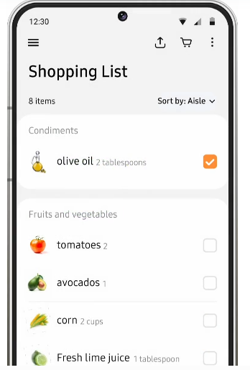

Figure 1. : Samsung Food grocery list section

These screenshots were taken directly from Samsung Food website (Samsung Food, 2024). Copyright 2024 SamsungFood. All rights reserved

* + List of features to adapt: user friendly user interface, meal planner, shopping list generator from recipe, ability to save online recipes in app, ability to have edit recipes based on servings and metric system, sharing recipes with others and a good login process (setting user preferences)
  + List of features to avoid: Not having a save offline option for meal planner, shopping list and recipes

## 1.4.2 Recipe app name: SuperCook

* + Platform: Android, iOS and website
  + Description of system: SuperCook is a recipe search engine that allows users to find recipes based on the ingredients they have in their pantry, manage their shopping lists and save their favourite recipes.
  + A screenshot of a phone

    Description automatically generatedA screenshot of a phone

    Description automatically generatedA screenshot of a phone

    Description automatically generatedScreenshots:

Figure 1. : SuperCook's shopping list manager

Figure 1. : SuperCook's ingredient filter

Figure 1. : SuperCook's favourites page with missing ingredient

These screenshots of the SuperCook app were taken directly from the app. Copyright 2024 SuperCook. All rights reserved

* + List of features to adapt: Ingredient filtering and dietary filtering, having a digital pantry as well as showing what missing ingredients is in the recipe
  + List of features to avoid: having long page of ingredient options, the overwhelming use of ads and recipes are very long winded

## 1.4.3 Recipe app name: Yummly

* + Platform: Android, iOS and website
  + Description of system: Is an app/website that helps users find recipes that are right for them using artificial intelligence to figure out recipes that meet their dietary, allergy and unique taste preferences. It allows users to plan their meals, search recipes using ingredients they have a smart thermometer feature. Yummly makes use of big data which allows them to recommend the recipes based on dietary needs, taste preference and if they are allergic to any ingredients
  + A screenshot of a recipe

    Description automatically generatedA screenshot of a menu

    Description automatically generated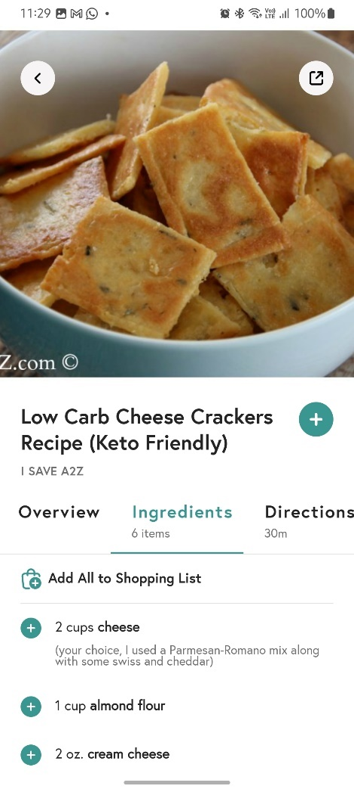Screenshots:

Figure 1. : Yummly's meal planner

Figure 1. : Yummly's shopping list manager

Figure 1. : Yummly's nicely laid out Ingredients

These screenshots of the Yummly app were taken directly from the app. Copyright 2024 Yummly. All rights reserved.

* + List of features to adapt: Uniform user experience, very nice design, categorizing shopping lists based on recipe or category, time a recipe takes, layout of screens and very comprehensive recipe details page, integration with phone calendar and their smart thermometer which provides guidance as one cooks.
  + List of features to avoid: Not having a save offline option for recipes and subscription plans

# 1.5 Project Plan

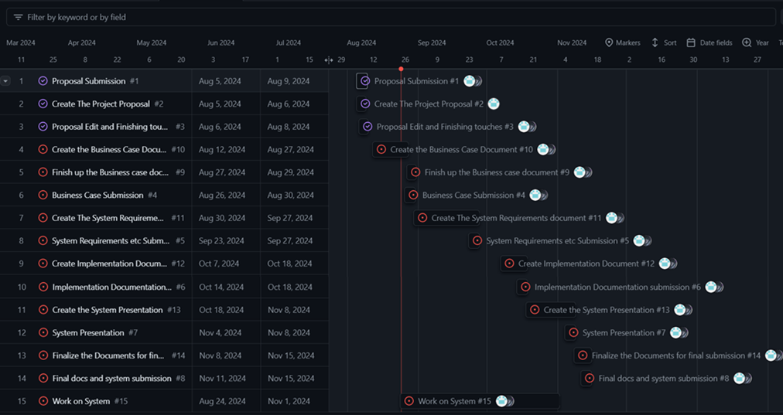

Figure 1. : The Roadmap for the project (ITPV302_PROJECT_Plan, n.d.)

In figure 1.12 above, is the current roadmap for the project. The major deliverables are laid out and along the way the minor deliverables are added. The minor deliverables relate to the delegation of the work to the different team members.

In Table 1.3 the start and end dates are shown for the deliverables. The end date is the date that the deliverable needs to be submitted by.

Table 1. : The major deliverables of the project

|  |  |  |
| --- | --- | --- |
| Deliverable | Start date | End date |
| Project Proposal Submission | 5 August 2024 | 9 August 2024 |
| Business Case Submission | 26 August 2024 | 30 August 2024 |
| System Requirements, Specifications and Technical Design Submission | 23 September 2024 | 27 September 2024 |
| Implementation Documentation Submission | 14 October 2024 | 18 October 2024 |
| System Presentation | 4 November 2024 | 8 November 2024 |
| Final Documents and System Submission | 11 November 2024 | 15 November 2024 |

Each major deliverable requires that the minor deliverables be completed before it can be completed.

The work is split up evenly between the group members, the work done by a member is reviewed by the other members to ensure that the information is relevant and well structured.

Communication:

Discord – main line of communication

Outlook (email) – Backup line of communication if there is an issue with Discord.

# 1.6 Risk Analysis

## 1.6.1 Data Loss

* Type of risk: Avoidable Risk
* How to handle: Implement regular backups and store them in

multiple locations. Make use of version control

systems like Git.

## 1.6.2 Miscommunication about requirements

* Type of risk: Minimizable Risk
* How to handle: Regular communication and discussion about what

the requirements are which can be done through

weekly meetings. Ensure that every member of the

reviews and agrees on the requirement changes

being made

## 1.6.3 Power Outages

* Type of risk: Minimizable Risk
* How to handle: Make use of cloud-based tools and services that

that automatically save and synchronize work

online. Consider investing in a backup power

source (solar or uninterruptible power supply) if

possible, or work in places with reliable power

sources.

## 1.6.4 Skills gap within the team

* Type of risk: Minimizable Risk
* How to handle: Identify areas where our team may be lacking skills

and find online tutorials, ai and documentation.

Allocation of tasks should be based on team

members’ strengths.

## 1.6.5 Data Security Issues

* Type of risk: Avoidable Risk
* How to handle: Implement security best practices, such as

encryption of user passwords and secure

authentication methods.

## 1.6.6 Misalignment of project scope

* Type of risk: Minimizable Risk
* How to handle: Ensure constant communication with lecturer to

ensure our current project aligns with the project

scope and specification. If unsure, best to ask.

## 1.6.7 Regulatory Compliance Issue

* Type of risk: Avoidable Risk
* How to handle: Ensure compliance with data protection laws such

as POPIA in South Africa and dietary information

standards.

## 1.6.8 Team member illness/ Unforeseen Circumstances

* Type of risk: Minimizable Risk? or is a transferrable risk?
* How to handle: Ensure all work related to the project is well

document (comments in code, descriptions for

what is being done different parts of the

development process) so that someone else can

pick up the work if needed.

## 1.6.9 Limited access to software (Trail software, require subscription)

* Type of risk: Acceptable Risk
* How to handle: Work around these limitations by finding freely

available alternatives or if possible, establish a

budget for this software.

## 1.6.10 Minor Bugs or Issues in the Code

* Type of risk: Acceptable Risk
* How to handle: Prioritize fixing critical issue/bugs first and allocate

time for testing and debugging. Also once solved,

document these issues for future reference.

## 1.6.11 Outdated project deliverable documents

* Type of risk: Avoidable Risk
* How to handle: Ensure documentation is updated during the

development process and shared

.

# References

Allied Market Research. (2019, September). *South Africa Fast Food Market Size, Share, Competitive Landscape and Trend Analysis Report, by Product Type, Age Group and Distribution Channel : Opportunity Analysis and Industry Forecast, 2019-2026.* Retrieved August 25, 2024, from Allied Market Research: https://www.alliedmarketresearch.com/south-africa-fast-food-market#:~:text=Urbanization%20is%20one%20of%20the,and%20adoption%20of%20busy%20lifestyle.

AllRecipes. (2022, September 21). *AllRecipes*. Retrieved August 25, 2024, from Cuisine A-Z: https://www.allrecipes.com/cuisine-a-z-6740455

Botev, V. (2018, July 30). *Recipe App Case Study*. Retrieved August 25, 2024, from Medium: https://medium.com/@velichko.botev/recipe-app-case-study-986af9c28207#8cc6

Davis, E. (2024, March 23). *Every Last Recipe*. Retrieved from Why Are Recipe Sites So Bad? Unpalatable Truths: https://everylastrecipe.com/why-are-recipe-sites-so-bad-unpalatable-truths/

Discovery. (2018, August). *Technofoodology: How is technology shaping your food future?* Retrieved August 25, 2024, from Discovery: https://www.discovery.co.za/corporate/nutrition-how-technology-shapes-your-food-future

Fance, C. (2023, March 16). *12 best cooking and recipe apps in 2024.* Retrieved August 25, 2024, from Android Police: https://www.androidpolice.com/best-cooking-recipe-apps/

FoodPrint. (2024, February 28). *The Problem of Food Waste.* Retrieved August 25, 2024, from FoodPrint: https://foodprint.org/issues/the-problem-of-food-waste/?cid=5664

Google Trends. (n.d.). *Google Trends*. Retrieved August 26, 2024, from https://trends.google.com/trends/explore?cat=71&date=today%205-y&geo=ZA&q=recipes&hl=en

Innova Market Insights. (2024, April 15). *Global Food Trends – Home Kitchen Heroes: Top 10 Trends 2024.* Retrieved August 25, 2024, from Innova Market Insights: https://www.innovamarketinsights.com/trends/global-food-trends/#:~:text=As%20part%20of%20eating%20at,after%20the%20COVID%2D19%20pandemic.

ITPV302_PROJECT_Plan. (n.d.). *GitHub*. Retrieved August 24, 2024, from https://github.com/users/NathanTh3Gr3at/projects/3/views/4

Lumley, S. (2024, April 10). *Indecisive Brits spend 37 hours a year trying to choose what meals to eat, study finds.* Retrieved August 25, 2024, from Wales Online: https://www.walesonline.co.uk/news/uk-news/food-mealtimes-indecision-dinner-choices-28968056

Rodale, M. (2017, December 6). *Too Busy To Cook?* Retrieved August 25, 2024, from HuffPost: https://www.huffpost.com/entry/too-busy-to-cook_b_802655

Samsung Food. (2024, March 28). *Samsung Food.* Retrieved August 25, 2024, from Samsung Food: https://samsungfood.com/

SuperCook. (n.d.). *SuperCook*. Retrieved August 25, 2024, from SuperCook: https://www.supercook.com/#/desktop